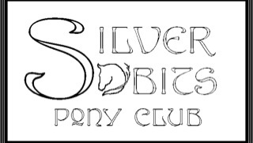
North Iowa: Silver Bits Pony Club
http://silverbitsponyclub.wix.com/silverbitsponyclub

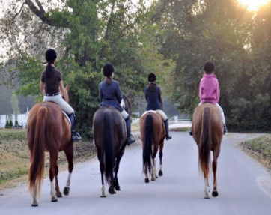
Des Moines: Irish Run Riding Center
http://www.irishrunfarms.com/pages/ponyclub.html

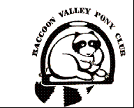
Central Iowa: Raccoon Valley Pony Club
http://www.raccoonvalley.ponyclub.org

Eastern Iowa: Timber Ridge Pony Club
http://timberridge.ponyclub.org/

Eastern Iowa: Quad Cities Pony Club
http://qcponyclub.com

SE Iowa: Prairie Jumpers Pony Club
cariebarnes3@gmail.com

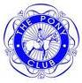
Western Iowa / Nebraska: Ponca Pony Club katharine.mcleese@nmhs.org

